Pastimes Online Clothing Store
Eugene mclane |
DEVTEAM PASTIMES
Chelsea Solomons: ST10398698 & Tshiamo kevin mbatha: st10070515 & Dan: ST10408413
2026
Table of Contents
Update Project Plan 2
1. Project Overview 2
2. Client Needs 2
3. Strategic Objectives 4
4. Project Scope 4
5. Site map 15
CONCLUSION 21

Figure 1Work Breakdown Structure 7
Figure 2 Milestones 8
Figure 3 DevOps Lifecycle 12
Figure 4 Sitemap 16
Figure 5 Website Home Page Wireframe 17
Figure 6 Website Registration Wireframe 18
Figure 7 Wireframe 3 18
Figure 8 Wireframe 4 19
Figure 9 Wireframe 5 20

Update Project Plan

Project Overview
The Pastimes Online Clothing Store is a small clothing business owned by Eugene McLane. My main goal for the Pastimes Online Clothing Store was to build a web-based clothing store. I wanted to make it easier for customers to look at clothes and buy things. I also wanted to help the seller manage stock and orders better.
The first version of the project showed me that there were some problems to fix. Customers had time finding the clothes they wanted because the business used many ways to show products. The seller also struggled with doing everything by hand like managing clothing listings, stock info and sales.
The new system fixed these problems by creating an online clothing store. The system gave tools to both buyers and sellers. Buyers could sign up, log in to browse clothing, see product details, put items in a cart and place orders. Sellers could manage clothing records and keep an eye on transactions.
For XISD6329 I am growing the Pastimes Online Clothing Store from a website into a mobile application. The new solution will have both a website and an Android mobile application. This change gives customers a way to look at the Pastimes clothing catalogue while keeping all the features.
In the XISD6329 module I am required to build both the website and the mobile application. I will use the project plan requirements analysis and system design that I already made.
I will also use the DevOps lifecycle for this updated project. Using the DevOps lifecycle will help me work better with others, test the software management versions and deploy the code smoothly.

Client Needs
The Pastimes Online Clothing Store project was made to satisfy the needs of the client Eugene McLane. The existing business needed a place to display clothing products and to handle the related operational information.
The main client needs that were found during the project are discussed below:
Improved Customer Access

Customers need a way to reach the clothing products without relying on separate physical or digital channels. The website and mobile application will give customers a platform where they can see and examine the clothing.
Customers should be able to:
- Register for an account.
- Log into the system.
- Browse clothing.
- View product information.
- Add clothing items to a cart.
- Complete an order.
- View Pastimes customers’ orders.
Improved Inventory Management
The seller needs a way to manage clothing inventory. The existing system design allows the seller to create, read, update and delete clothing records.
The seller should therefore be able to:
- Add clothing records.
- View existing clothing.
- Edit clothing information.
- Remove clothing records.
- Monitor stock availability.
- Review sales information.
Improved Transaction Management
The client needs transactions to be stored systematically than relying on fragmented manual records. The tblorder table records the customer, clothing item order date, quantity and total amount for each order.
This allows the system to provide:
- Order records.
- Customer order history.
- Sales information.
- Transaction information, for clothing items.
Mobile Accessibility
The original XISD5319 project focused on the website. The XISD6329 project extends the solution by adding an Android mobile application.
The mobile application will give users another interface to access the Pastimes system. The core functionality of the application will stay aligned with the existing requirements and database structure.
The updated Pastimes solution therefore meets the clients’ need for a clothing platform that improves customer access, inventory management and transaction management while extending the system to devices.

Strategic Objectives
The main goal for the Pastimes Online Clothing Store project is to build a web and mobile application that helps people buy and manage clothing products.
The Pastimes Online Clothing Store project has these objectives:
- Pastimes Online Clothing Store will build a clothing store that is easy for everyone to use.
- It will make it easy for customers to find the clothing they want.
- It will let customers create accounts and sign in safely.
- It will let customers browse and check out clothing products.
- Include a shopping cart and a payment method.
- Keeps a record of all orders in customers’ place.
- Give sellers tools to manage their inventory.
- Allow sellers to add, modify or delete clothing listings.
- Pastimes Online Clothing Store will provide sellers with reports on sales and inventory.
- It will create an Android app that complements the website.
- Ensures the website and mobile app function correctly.
- It will use GitHub to track all code changes.
- Pastimes Online Clothing Store will follow the DevOps lifecycle during system development.
- Tests the system before it goes live.
- It will build a working prototype that users can test and provide feedback to improve.

Project Scope
Website Scope
The website will offer these features:
Public features
- Landing page
- Registration
- Login
Buyer features
- Product catalogue
- Product details
- Shopping cart
- Checkout
- Order history
Seller features
- Seller dashboard
- Inventory management
- Add clothing
- Edit clothing
- Delete clothing
- Sales reporting
Mobile Application Scope
The Android application will provide a way to use the Pastimes features.
The mobile application will include:
- Splash screen
- Login
- Registration
- Buyer home screen
- Product catalogue
- Product details
- Cart
- Checkout
- Order history
- Seller dashboard
- Inventory management
The mobile application will be built to match the features and data structure of the website.
Database Scope
The current system uses a database with three tables:
- Tblusers
This holds info for users.
- Tblclothes
This holds info for clothing inventory.
- Tblorder
This holds info for transactions and orders.
The first project named these entities:
- User
- Clothes
- Order
The XISD6329 project will keep this setup unless we need to change things while we build it.
Updated Work Breakdown Structure
The project covered planning, requirements, design making a prototype, testing and launching.
The new WBS adds work for development and DevOps.
Pastimes Online Clothing Store
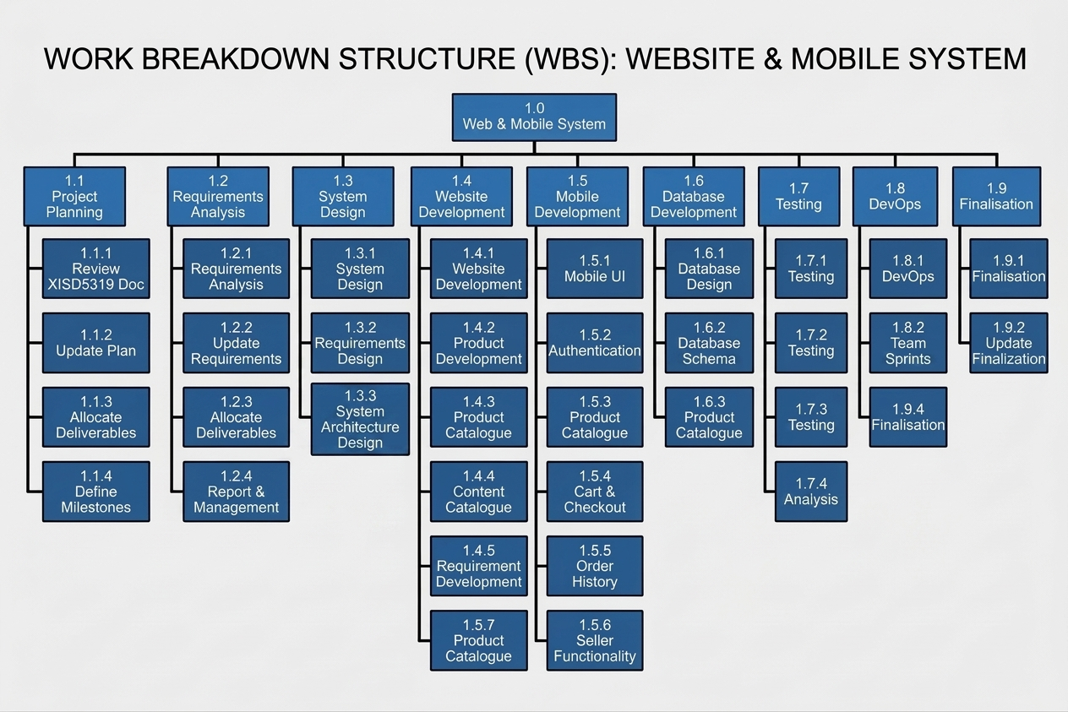
Figure 1Work Breakdown Structure
Updated Project Milestones
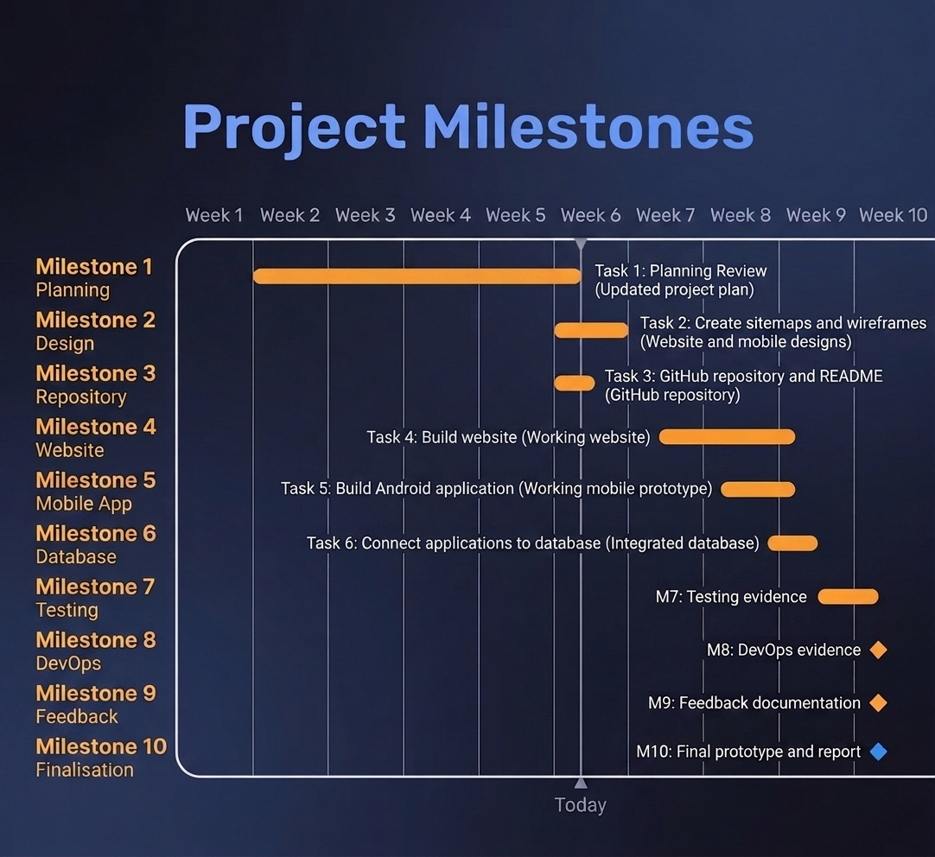
Figure 2 Milestones

Team Member Deliverables and Responsibilities
There are two people on this project. We have split the work based on what needs to be done to make sure both team members help with the system.
Deliverable | Chelsea Solomons | Tshiamo Kevin Mbatha | Dan
Project planning | Lead | Support | Support
Requirements analysis | Lead | Lead | Lead
System design | Support | Lead | Support
Website UI | Support | Support | Lead
Website development | Support | Support | Lead
PHP/backend development | Lead | Support | Support
Mobile application UI | Support | Support | Lead
Mobile application development | Support | Support | Lead
Database design | Support | Lead | Support
Database implementation | Support | Lead | Support
Testing | Support | Lead | Support
Debugging | Lead | Lead | Lead
Github management | Lead | Support | Support
DevOps planning | Lead | Lead | Lead
Sitemap | Joint | Joint | Joint
Wireframes | Joint | Joint | Joint
Documentation | Lead | Support | Support
Final report | Lead | Review | Review
Both are responsible for talking to each other, checking each other’s work and making sure we hit all project milestones.
DevOps Lifecycle
We are using the DevOps lifecycle to help with building, testing, getting feedback and making things better.
The module asks us to use the DevOps lifecycle and tools like Azure DevOps or something similar. We also need to use Kanban boards, Git repositories and automated ways to test and deploy.
Plan
When we plan, we look at the XISD5319 project papers. We decide what needs to change for XISD6329.
Tasks include:
- Looking at requirements.
- Finding what the mobile application needs.
- Updating the project plan.
- Giving out tasks.
- Setting project milestones.
- Making a development backlog.
Code

The team will build the website and the Android application using the designs we agreed on.
Website development will use:
- HTML
- CSS
- PHP
- JavaScript if needed
- MySQL integration
Mobile development will focus on making the screens and features work.
Build
We will put all the parts of the application into working builds.
This involves:
- Linking the parts of the application.
- Connecting the database.
- Checking that everything works together.
- Getting the website ready to launch.
- Getting the Android application ready for testing.
Test
We will test things while we build, not at the end.
Testing tasks include:
- Unit testing.
- Integration testing.
- Checking forms.
- Testing logins.
- Database testing.
- Website interface testing.
- Mobile interface testing.
- Functional testing.
Release
Once testing is done, we will get versions of the system ready to show.
The team will check that:
- All features work.
- Big bugs are fixed.
- The database connects right.
- The website and mobile application look like the designs.
Deployment
We will get the website ready to go and install the Android application on a phone to test it.
The module says the application must run on a mobile phone not just a computer program.
Operate
The team will watch how the system works after it is launched.
Tasks include:
- Watching how the application works.
- Checking on the database.
- Finding any errors in the application.
- Keeping the GitHub repository up to date.
- Writing down any issues that are not fixed.
Monitor
The team will watch for:
Application errors.
- Database errors.
- Login problems.
- User interface issues.
- Mobile application issues.
- Functional bugs.
Any issues we find while monitoring will go into the development backlog.
Feedback and Continuous Improvement
We will use feedback from the lecturer, the client and the team to make things better.
The feedback process helps us to:
- Find an issue.
- Write down the issue.
- Decide which issue is most important.
- Give the task to a team member.
- Fix the issue.
- Test the fix.
- Release the version.
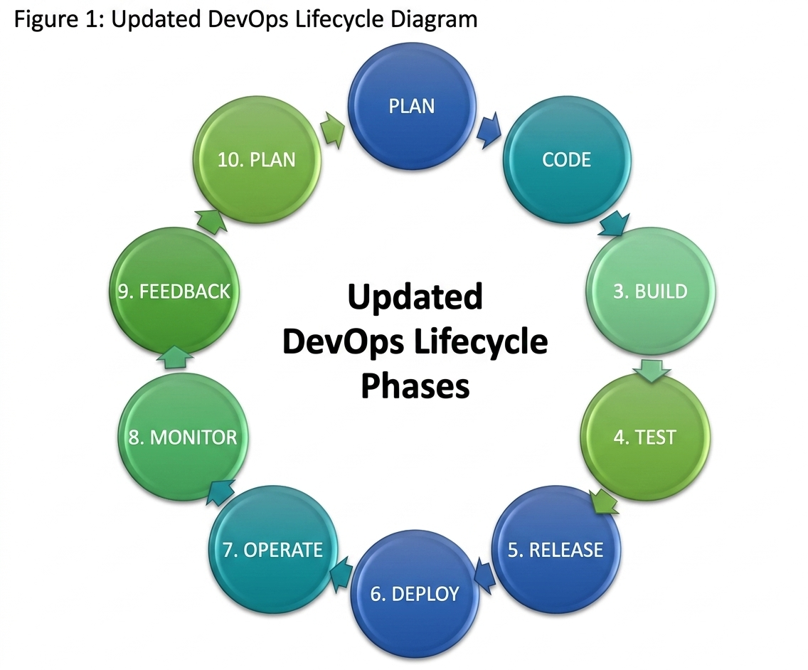
Figure 3 DevOps Lifecycle
Development Tools and Technologies
We will use the tech from XISD5319, plus new tools for mobile development and DevOps.
Technology/ Tool | Purpose
HTML5 | Website structure
CSS3 | Website presentation and responsive styling
PHP | Server-side application logic
MySQL | Relational database
XAMPP | Local PHP/ Apache/ MySQL development environment
phpMyAdmin | Database administration
GitHub | Source-code management and version control
Figma | Wireframes and UI/U design
Android Development Tools | Mobile application development
Word | Project documentation
DevOps/ Kanban tool | Task management and lifecycle tracking

The XISD6329 module lists GitHub, Microsoft Office and Visual Studio as tools we can use and require DevOps work throughout the project.
Risk Management
The risks from XISD5319 are still there. We have added new risks, for development and DevOps.
Risk | Severity | Mitigation
Database corruption | High | Use database constraints, backups and controlled database updates
Database connection failure | High | Test database connections regularly and maintain consistent development environments
Technical stack failure | High | Standardise the XAMPP development environment
Mobile compatibility problems | High | Test the application on a physical Android device
Integration errors | High | Perform integration testing throughout development
Low user adoption | Medium | Maintain a simple and consistent interface
Data validation problems | Medium | Implement form validation and sanitisation
GitHub merge/conflict issues | Medium | Commit regularly and communicate before modifying shared files
Missed deadlines | Medium | Use milestones and Kanban task tracking
Loss of project files | High | Maintain GitHub version control and regular commits
Authentication vulnerabilities | High | Apply appropriate password protection and session controls
Scope expansion | Medium | Maintain the approved project scope and prioritise required functionality

Updated Economic Feasibility
The first plan for the project had a budget of R230,800 for 1,240 hours.
The new plan still uses the development resources. We are adding mobile application development and DevOps activities to the project scope.
Task | Responsible Member(s) | Estimated Effort
Project planning | Chelsea | 80 hours
Requirements review | Chelsea, Tshiamo & Dan | 80 hours
System design update | Chelsea, Tshiamo & Dan | 80 hours
Website development | Dan | 200 hours
Mobile application development | Chelsea, Tshiamo & Dan | 240 hours
Database implementation | Tshiamo | 120 hours
Testing and debugging | Chelsea, Tshiamo & Dan | 160 hours
DevOps implementation | Chelsea, Tshiamo & Dan | 100 hours
Documentation | Chelsea, Tshiamo & Dan | 100 hours
Total |  | 1160 hours

This new estimate is for planning and is not a final price. The actual work time might change as we do development, testing and feedback.
Project Plan Updates from XISD5319
I have made updates to the project plan to fit the needs of XISD6329.
Original project
The XISD5319 project was about making a web-based Pastimes Online Clothing Store using PHP, HTML, CSS, MySQL and XAMPP.
Updated project
The XISD6329 project adds more to the solution, such as:
- An Android application.
- Mobile-specific wireframes.
- A mobile application sitemap.
- Making sure the Website and mobile UI consistency is there.
- A DevOps lifecycle.
- Continuous testing.
- Version-controlled development.
- Planned release and deployment activities.
- Keeping up with database integration.
The module needs the project documentation, from XISD5319, to be updated so that everything matches the project briefly.
The project still solves the Pastimes business problem, but the technical solution is now bigger to work on different platforms.

Site map
Website site map
When you visit the website, you first see a landing page. Users can register for an account. Log in.
Once you are signed in buyers can access the product catalog. Look at each clothing item. Buyers can add items to the cart before proceeding to check out. Buyers can also view their orders.
Sellers use a dashboard that lets them manage inventory and handle sales.
Mobile application Site Map
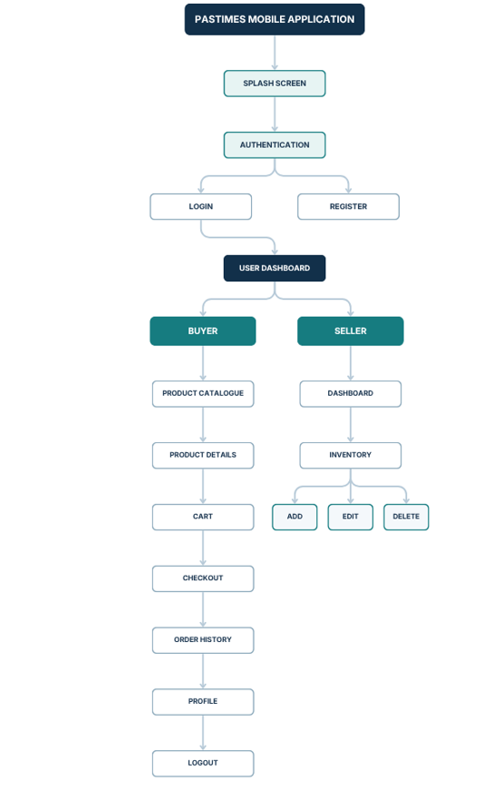
Figure 4 Sitemap
Website Wireframes
Website wireframes give a preview of the website before it is fully built.
- Consistent navigation.
- Clear content hierarchy.
- Product visibility.
- Simple user interactions.
- Separation between buyer and seller functions.
- Responsive presentation.
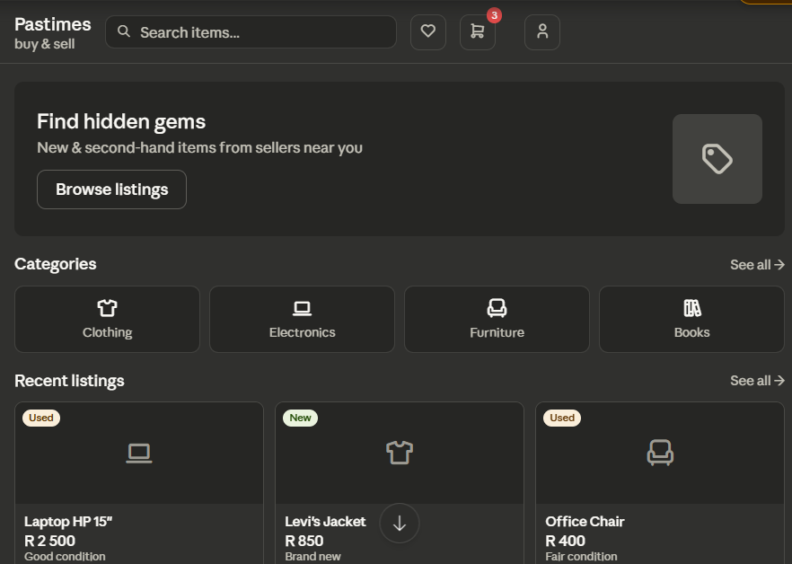
Figure 5 Website Home Page Wireframe
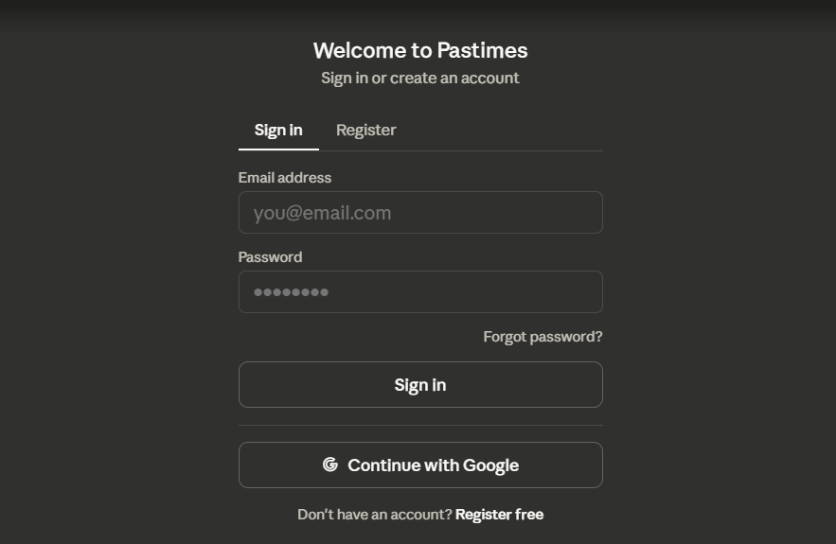
Figure 6 Website Registration Wireframe
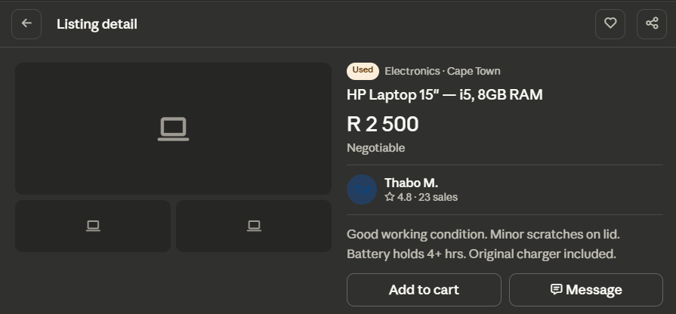
Figure 7 Wireframe 3
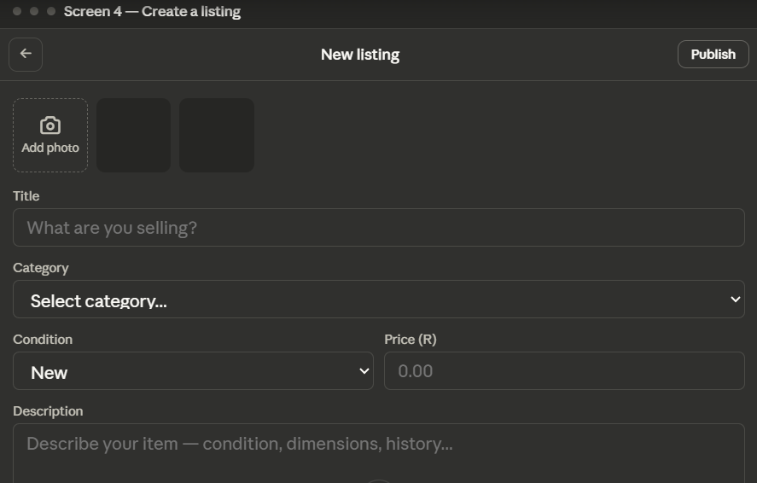
Figure 8 Wireframe 4
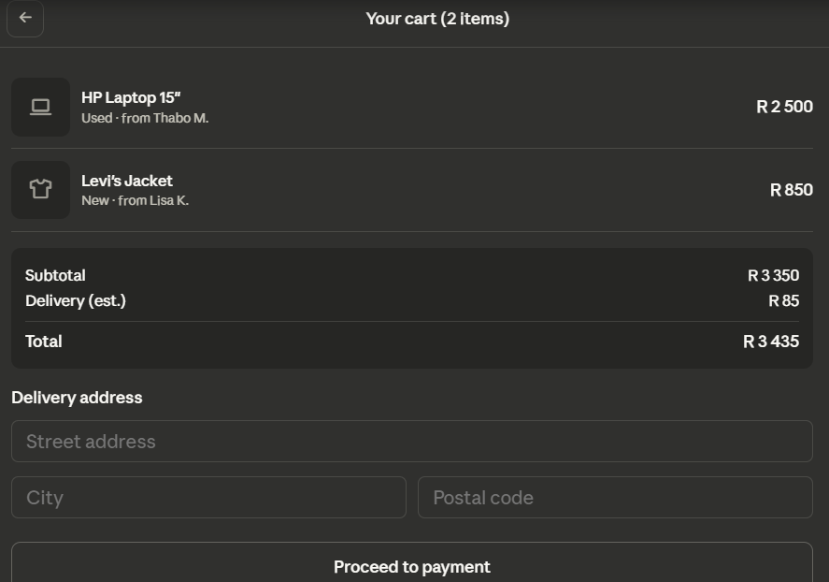
Figure 9 Wireframe 5
Design Consistency Between Website and Mobile Application
The website and mobile application will follow the same overall system structure and business logic.
The purpose of maintaining design consistency is to ensure that users can move between platforms without having to learn an entirely different system.
The following elements will remain consistent:
Website | Mobile Application
Pastimes branding | Pastimes branding
Login | Login
Registration | Registration
Product catalogue | Product catalogue
Product details | Product details
Cart | Cart
Checkout | Checkout
Order history | Order history
Seller dashboard | Seller dashboard
Inventory management | Inventory management
Sales information | Sales information

The main difference lies in how the page's shown and how users navigate. The website displays products and controls them across a screen. The mobile app stacks content vertically, uses buttons and uses navigation.

CONCLUSION
We build the updated Pastimes Online Clothing Store project on the system from XISD5319. We also meet the needs of XISD6329.
We defined the business problem listed the requirements designed the architecture, set up the database and created a web prototype. The updated project adds an Android app, a refreshed website wireframes that match sitemaps and a DevOps life cycle.
We keep the database: tblusers, tblclothes, tblorder. This keeps the requirements, design and implementation in sync.
We split tasks between Chelsea Solomons and Tshiamo Kevin Mbatha and set milestones. We list the tools and technologies needed for the work.
We allow buyers to see clothing items use a shopping cart and place orders. Sellers can manage stock. View sales data. Both interfaces keep the core functions. Adjust their look for each platform.
We use GitHub for source code and regular commits. The DevOps life cycle covers planning, building, testing, releasing, deploying, monitoring and continuous improvement.
We give a base to move from the Task 1 designs, to the build and test phases of the Pastimes Online Clothing Store project. The XISD6329 module then requires that the working prototype be made and tested, covering the Android app, the database and the DevOps work.

